Week Beginning Monday 25th May 2020

“Sports do not build character. They reveal it.”

SCHOOL NEWSLETTER

SPORTS DAY
A huge thank you to all our pupils and families for participating in this year’s Sports Day. It was clear to see from postings of photos and feedback that great fun was had completing the events. I am delighted that the weather has stayed kind to us! I will announce the winning House for this year’s Sports Trophy on Monday when all the points are counted and totals verified. Good luck everyone!
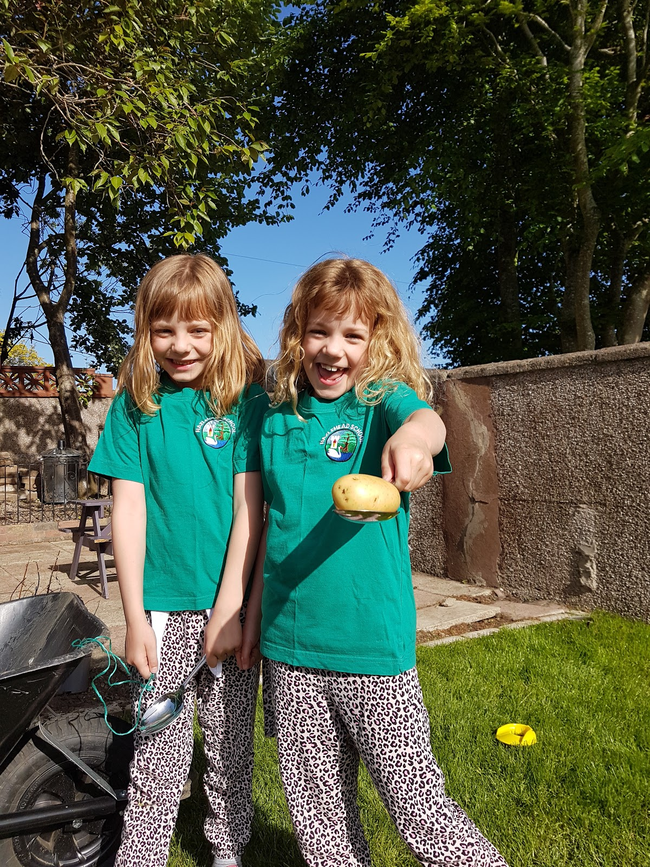
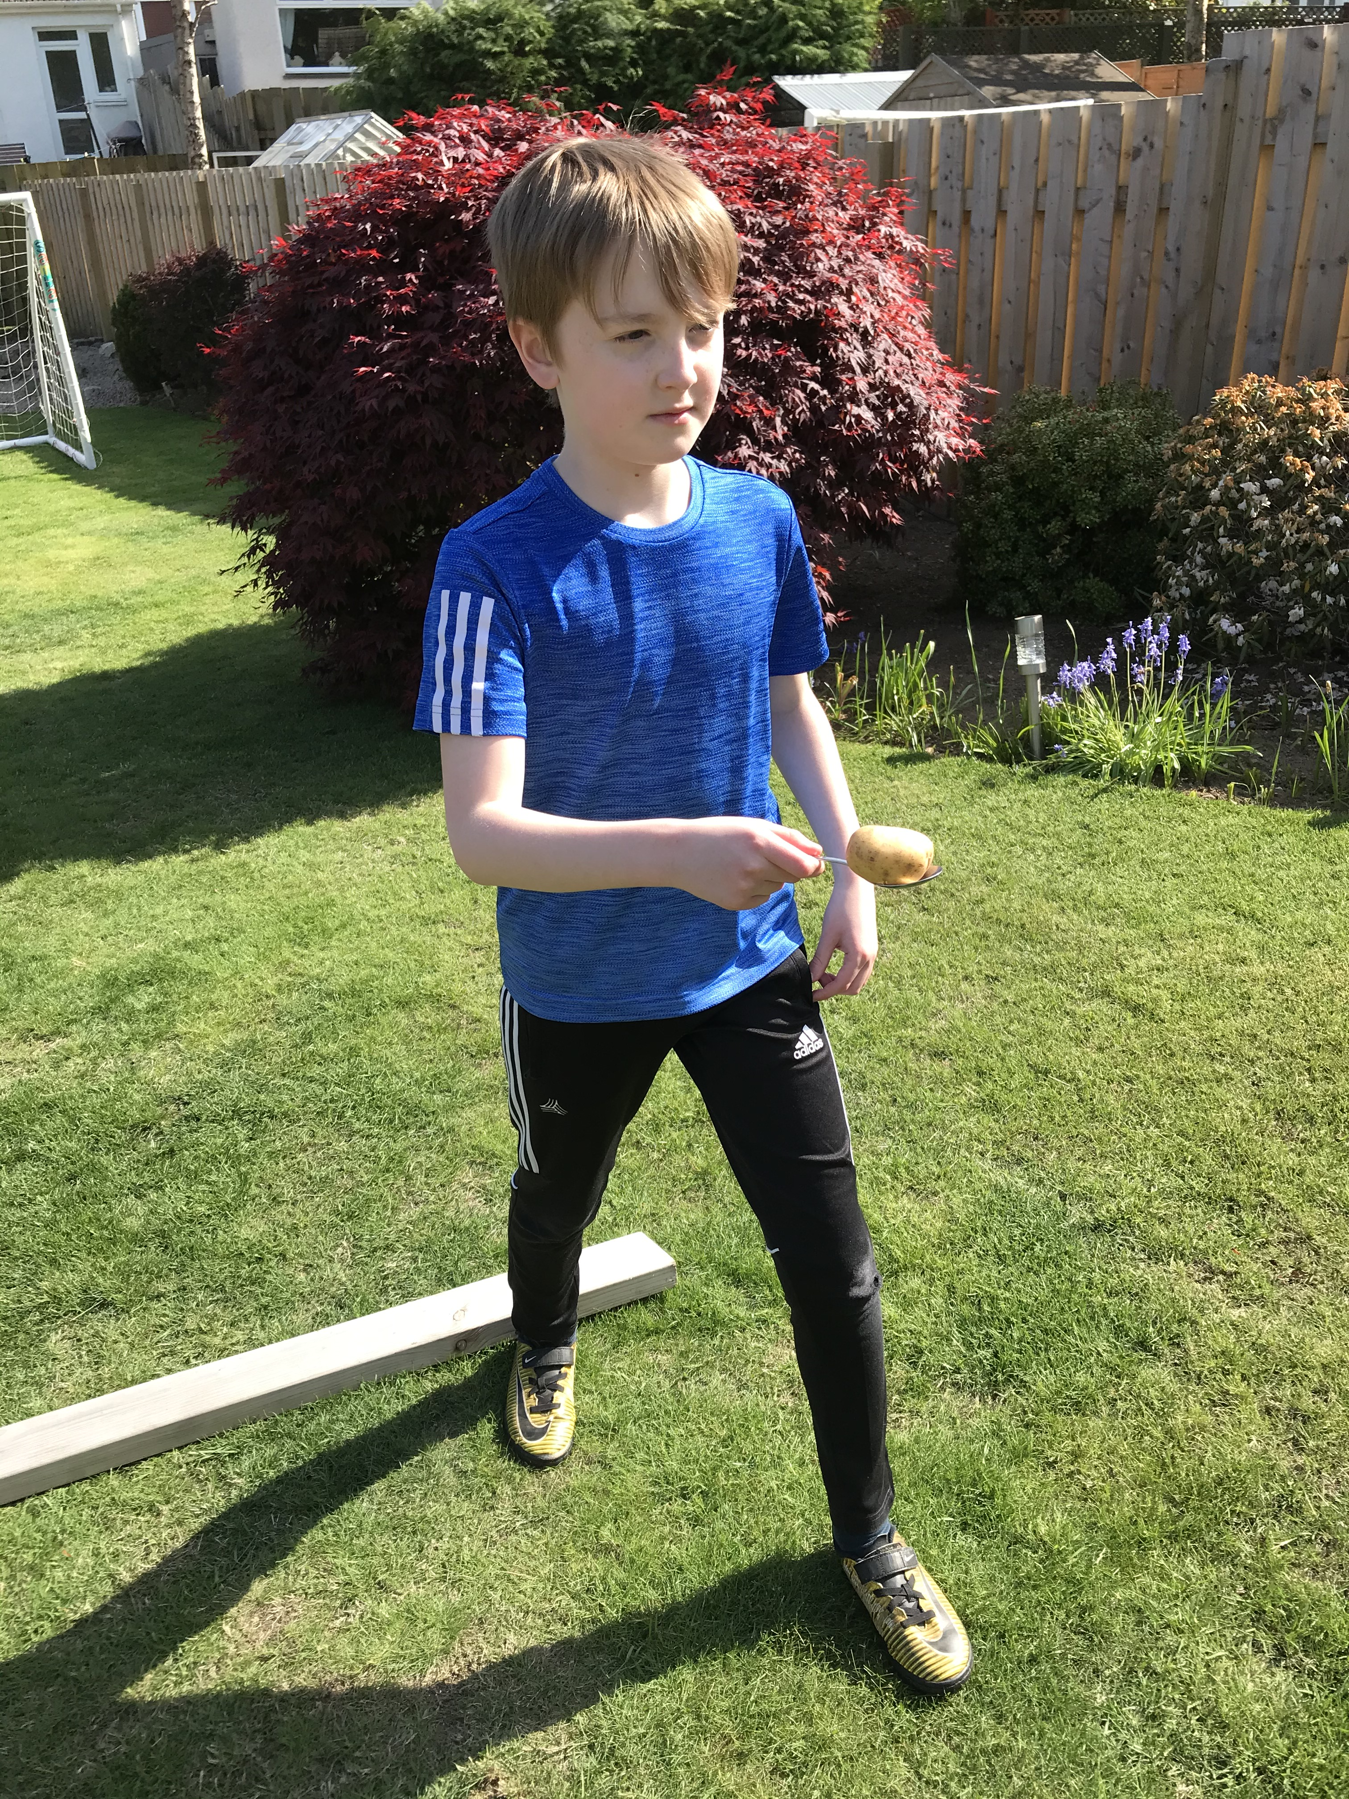

INTERNET SAFETY
- Please can I remind all our pupils and families the importance of appropriate internet use.
- The purpose of the Google connection is for school work first and foremost.
- The digital learning has been set up in a way that allows pupils to keep connected through the Google Stream and Google Meet which is supervised by the teacher.
- Please can I ask parents to reinforce this important message to their child if they are using Google Classroom unsupervised and ensure that you are monitoring your child’s use of it.

P1 TRANSITIONS
- The P1 transition process has been busy over the last 3 weeks.
- Information about the induction process has been shared with parents alongside a Virtual Tour giving a glimpse into what school will look like for our new children.
- Our current P1s are busy putting together information for our new pupils and this will be shared in a few weeks’ time.
- The School Handbook, P1 Passport, School Uniform Order form and a suggestion list of things to do before starting P1 have all been shared this week.
- Next week, we are looking forward to the ‘”Who’s Who” video of staff members at Hazlehead and our Early Years Practitioners will be starting their ‘Going to School’ story time which will be shared each week to spark conversations about the exciting move to Hazlehead School.
- Later in the term, our P6 pupils will be making Buddy Cards to share with our new P1 pupils and a “Who’s Who” video of our P1 teachers.
- We are very much looking forward to seeing all our new P1 pupils in August. In the meantime, if you have any questions, please do not hesitate in getting in touch.

P7 TRANSITIONS

I am aware that many of our P7 pupils are feeling very anxious and upset with the reality that they will not finish the year as they would have hoped. As a staff, we are also very disappointed as we pride ourselves on ensuring that this incredibly important milestone is memorably marked. Despite the significant barriers we face at the moment, we are looking into how we can still celebrate the P7 leavers that still adheres to the council’s health and safety policy. Please bear with us as we explore possibilities.

Finally, I can fully appreciate the huge anxiety returning to school in August is causing our families with many questions raised, particularly with the significant speculation on social media. At this stage it is very difficult to say what school will look like and how it will operate. As with all other schools, we will be guided by Scottish Government and Aberdeen City Council. Please be reassured that the health and safety of our pupils and staff will be at the forefront of any decisions made as that will always be our number one priority. Barbara Jones☺

